# *Lab 7 – CRC Card Introduction*

Date assigned: Monday, February 20, 2017

Date due: **Wednesday, February 22, 2016, 15:50**

**Learning Objectives**

Upon successful completion of this lab exercise, the student will be able to:

* Identify a list of candidate classes using brainstorming and Activity analysis
* Validate the list of classes using use case and activity diagram walk throughs.
* Design and Create UML Class diagrams
* Design and Create UML Sequence diagrams

Lab Set Up

1. Create a copy of this document called YourUsername_E21_L07.docx for E21 on your home drive.
2. Part A, B are group activities. All other parts are individual activities.
3. **All diagrams are to be done in LucidCharts**

To do:

# Part A – Brainstorm the Classes

Last week/lab, you used the grammatical analysis of the activities to find the candidate classes. This is just one technique. Alternative, you can brainstorm with your team to propose a list of classes.

Take a look at E21_S11, the project walkthrough for the parking lot system.

|  |  |  |  |
| --- | --- | --- | --- |
| Candidate Noun | Business Meaning | Is a Class? | Justification |
| Student | A student utilizing parking system | Yes | Actor |
| Parking lot admin | The admin validating the parking system | Yes | Actor |
| Omnivox | The system that is inside the parking lot system | Yes | Actor |
| User | Parent of admin and student | Yes | Parent of parking lot admin and Student |
| Admin UI | The UI for the parking lot admin to log in under | Yes | User interface, calls methods |
| Student UI | The UI for the students to log in under. | Yes | User interface, calls methods |
| Parking pass | The parking pass needs to associate to the user | Yes | Isn’t directly correlated to student, so is in its own class |

# Part B – Take your classes out for a test drive

1. Fill Out a CRC card for each of your Classes. See Appendix A for a template you can use to paste in your CRC’s below. Reference on how to fill in a CRC card can be found [here](http://agilemodeling.com/artifacts/crcModel.htm).
2. Role play the classes using the activity steps in E21_S11. Ensure that you track all the attributes and methods that each action requires. For simplicity, assume all user interaction is abstracted by a Class called UserInterface.

# Part C – Capture the Design – Class Diagrams

*Once you’re confident that your Classes cover the Activities, it is time to capture your design for others the witness the glory of it.*

1. From your CRC cards, create formal UML Class diagrams. Paste your diagram below:

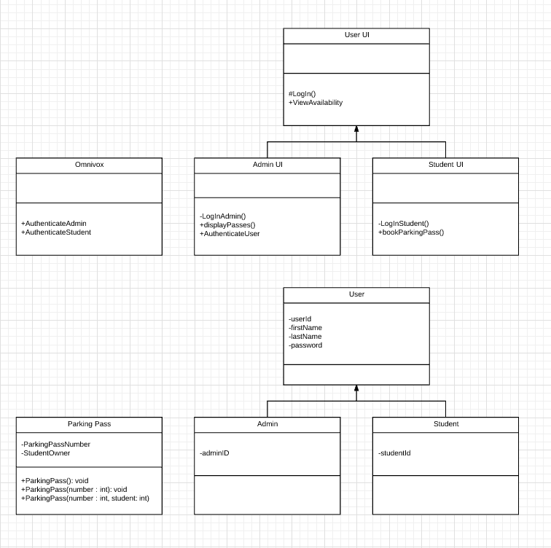

# Part D – Capture the Design – Sequence Diagrams

*Once you’re confident that your Classes cover the Activities, it is time to capture your design for others the witness the glory of it.*

1. From your informal CRC card walkthrough of the Activities, create a Sequence diagram for each independent action from the Activity diagrams of E21_S11. For now, skip Authentication and logging on.

# Part E - Assessment

1. What did you learn in completing this lab?
2. What did you have difficulty with?
3. What did you do well?
4. How many hours did you spend in completing this lab?
5. What took you the most time?

Mark breakdown

|  |  |
| --- | --- |
| **Part A** |  |
| Brainstorm Candidate Classes | 5 |
| **Part B** |  |
| 1. Generate CRCs by walkthrough | 10 |
| **Part C** |  |
| 1. Class Diagrams | 10 |
| **Part D** |  |
| 1. Sequence Diagrams | 20 |
| **Part D** |  |
| Self assessment and properly handed in, English | 5 |

To Submit

Upload the document in Word format to the Moodle page for this course.

# Appendix A

CRC Card Template

|  |  |
| --- | --- |
| **Class**: | |
| **Responsibilities** | **Collaborators** |
|  |  |
|  |  |
|  |  |
|  |  |